What do potential homebuyers consider before buying a home? Location, property size, proximity to offices, schools, parks, restaurants, hospitals, or typical white picket fences ? What about price, which is the most important factor?

Buying a home, especially in a city like Bangalore, is a difficult decision. The main factors are usually the same for all metros, but there are other factors to consider for the Silicon Valley in India. With the help of millennials, vibrant culture, great climate, and a wide range of employment opportunities, it is difficult to price a home in Bangalore.

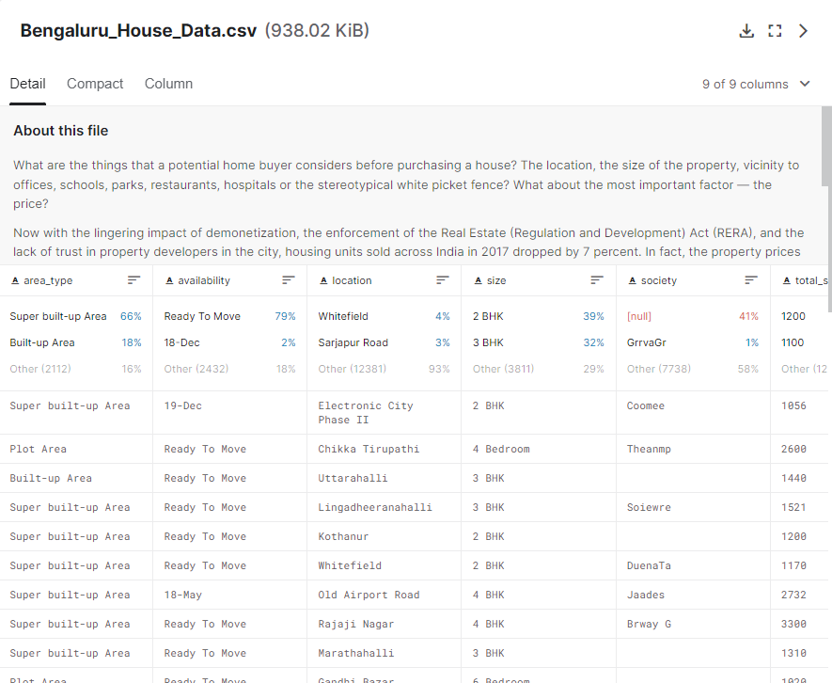In order to overcome the problem, we have used the Bengaluru house price datasets obtained from Kaggle.com for this project where various ML algorithms can be applied for predicting prices.

The dataset contains 8 major attributes affecting the price for prediction:

1) Area_Type

2) Availability

3) Location

4) Size

5) Society

6) Total_Sqft

7) Bath

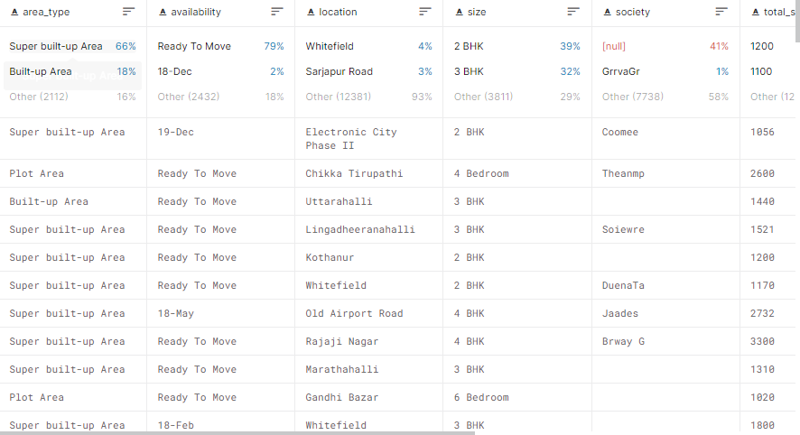8) Balcony